**Troops Func Spec**

1. **Unit Grab system**
   1. **Controls:** Player can grab Units by moving his targeting reticle over them with the right thumbstick, and pressing <RB> to pull them to him.
   2. **Mechanics:** Once units are selected they turn from physical form to particles, and the particles begin moving towards the player. The actual action of obtaining the units is proportional to their distance from the player.
2. **Unit Fire System**
   1. **Controls:** Player moves target reticle to the direction he wants to fire the units. When he presses <RT> the units stream out as particles for 20 feet and then begin walking / running in the direction the player has sent them.
   2. **Mechanics:** Units spend time summoning back to the battlefield as particles. Once Units have passed a threshold of 20 feet, they turn back into physical units, and head in the direction the player has sent them. They’ll engage anything within a “V” shaped arc in front of them.

**Unit Types**

Description of Stat effects are found in the GDD, under Stats in section 5.0. Player stats and Unit stats should be the same to keep things simple.

* **Unit Type Pseudo Code:** Inherits from MonoBehaviour. This class will most likely go under heavy revision, over the course of the next few weeks, depending how the State Machine(s) need to receive their data for attacks based on AI States.

1. 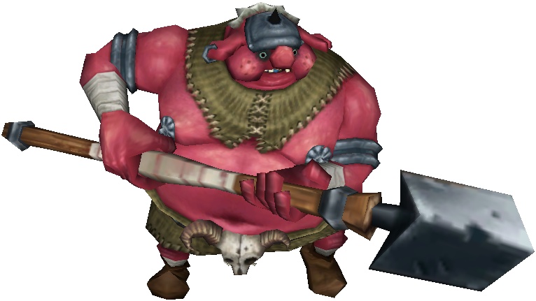

**Moblin:** A medium armored unit doing medium damage.

* 1. **Attacks**
     1. **Forward Spear Stab:** Stabs forward with spear rapidly for medium damage multiplier.
     2. **Spear Slash:** Slashes horizontally with spear slowly for medium damage multiplier.
  2. **Behaviors**
     1. **Grouped**: When grouped with other Moblins they prefer moving forward and synchronizing spear stabs.
     2. **Alone:** Attempts to move towards the player, and tends to switch between stabs and slashes based on players positioning. On occasion they will throw in a slash instead of a stab to keep the player on his toes, though.
  3. **Stats**

|  |  |
| --- | --- |
| **Strength** | **5** |
| **Attack Speed** | **10** |
| **Physical Defense** | **5** |
| **Magical Defense** | **5** |
| **Movement Speed** | **5** |
| **Health** | **50** |

1. 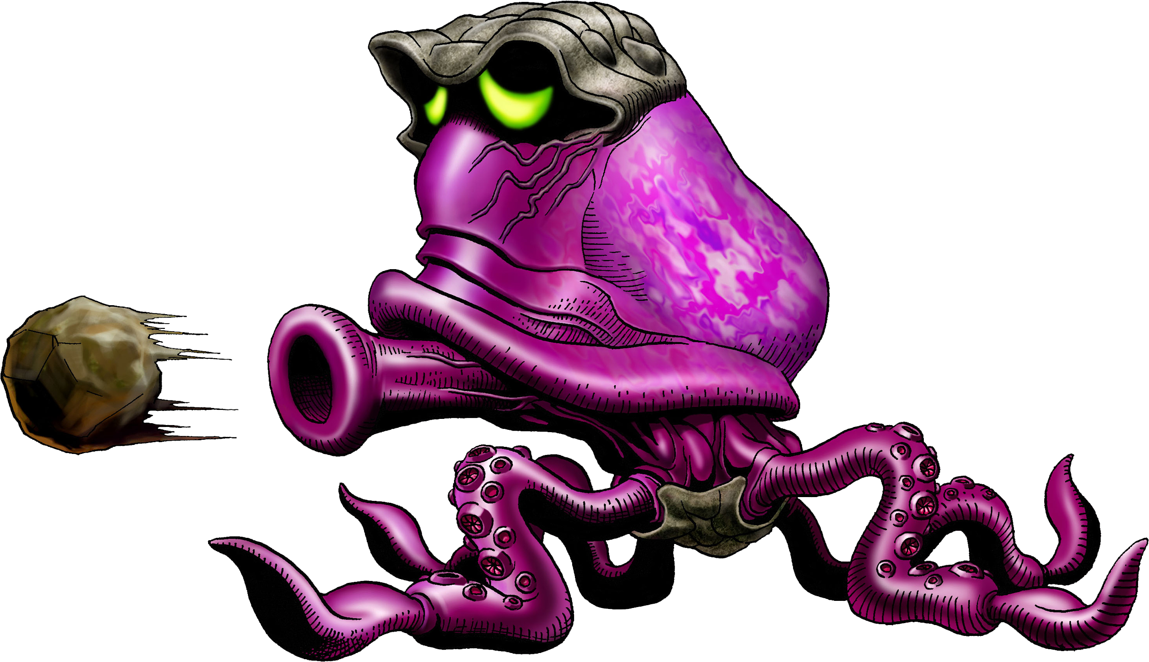

**Octoroks:** A low armored unit with a high damage range attack

* 1. **Attacks**
     1. **Rapid Rock Shot:** Shoots Rocks forward at high rate of speed for low damage multiplier.
     2. **Charged Rock Shot:** Charges up and Shoots one charged rock forward at a slow speed for a high damage multiplier.
  2. **Behaviors**
     1. **Grouped:** Attempts to form a line and fire rocks towards the opponent. Prefers using Rapid Rock Shot if enemies are far away, charged rocks for medium distance, and rapid Rock shot if enemies are close.
     2. **Alone:** Attempts to run from enemy and shoots Charged Rock Shot or Rapid Rock Shot based on distance between enemy and itself.
  3. **Stats**

|  |  |
| --- | --- |
| **Strength** | **10** |
| **Attack Speed** | **5** |
| **Physical Defense** | **1** |
| **Magical Defense** | **1** |
| **Movement Speed** | **5** |
| **Health** | **25** |

1. **Darknuts:** A slow unit with low damage and high armor.
   1. **Attacks**
      1. **Cleave :** vertical swing across battlefield with low damage multiplier.
      2. **Shield Slam:** Slams shield forward stunning the player for a second, and has a very low damage multiplier
   2. **Behaviors**
      1. **Grouped:** Attempts to surround player, and coordinates Shield Slams and Cleaves. Shield Slams fire off approximately once every 10 seconds with the frequency increasing the larger the group around the player is.
      2. **Alone:** Constantly tries to move behind the player. He primarily attacks the player with cleave. About every 5 seconds or so he attempts to land a shield slam.
   3. **Stats**

|  |  |
| --- | --- |
| **Strength** | **3** |
| **Attack Speed** | **5** |
| **Physical Defense** | **10** |
| **Magical Defense** | **10** |
| **Movement Speed** | **2** |
| **Health** | **100** |

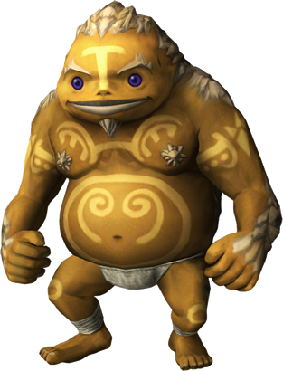

**Goron:** A High armor medium damage unit, with slow movement speed when walking, and fast movement speed when rolling.

**a.Attacks**

* + 1. **Fist Slam:** Punches straight forward at player with medium damage multiplier.
    2. **Roll:** Rolls at player at a high rate of speed. deals medium damage as long as Goron is still hitting the player.

**b. Behaviors**

* + 1. **Grouped:** Attempts to surround player. If no Goron is within a rectangle range in front of the Goron choosing its attack, the Goron will select the roll attack. Otherwise, The gorons attempt to form a mob around the player and use Fist Slam, until room opens for a roll attack. .
    2. **Alone:** If far away from the player the Goron uses his roll attack to hit the player. When the Goron gets close to the player he prefers Fist Slam, and based on a random roll mixes in roll attacks.

**c.Stats**

|  |  |
| --- | --- |
| **Strength** | **7** |
| **Attack Speed** | **3** |
| **Physical Defense** | **8** |
| **Magical Defense** | **8** |
| **Movement Speed** | **4** |
| **Health** | **75** |

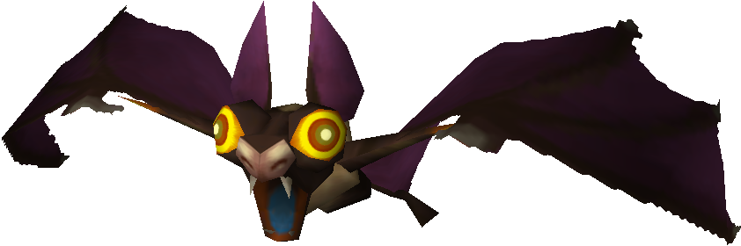

**Keese:** Small swarms of bats-like creatures

**a.Attacks**

* + 1. **Fist Slam:** Punches straight forward at player with medium damage multiplier.
    2. **Roll:** Rolls at player at a high rate of speed. deals medium damage as long as Goron is still hitting the player.

**b.Behaviors**

* + 1. **Grouped:** Attempts to surround player. If no Goron is within a rectangle range in front of the Goron choosing its attack, the Goron will select the roll attack. Otherwise, The gorons attempt to form a mob around the player and use Fist Slam, until room opens for a roll attack. .
    2. **Alone:** If far away from the player the Goron uses his roll attack to hit the player. When the Goron gets close to the player he prefers Fist Slam, and based on a random roll mixes in roll attacks.

**c.Stats**

|  |  |
| --- | --- |
| **Strength** | **7** |
| **Attack Speed** | **3** |
| **Physical Defense** | **8** |
| **Magical Defense** | **8** |
| **Movement Speed** | **4** |
| **Health** | **75** |

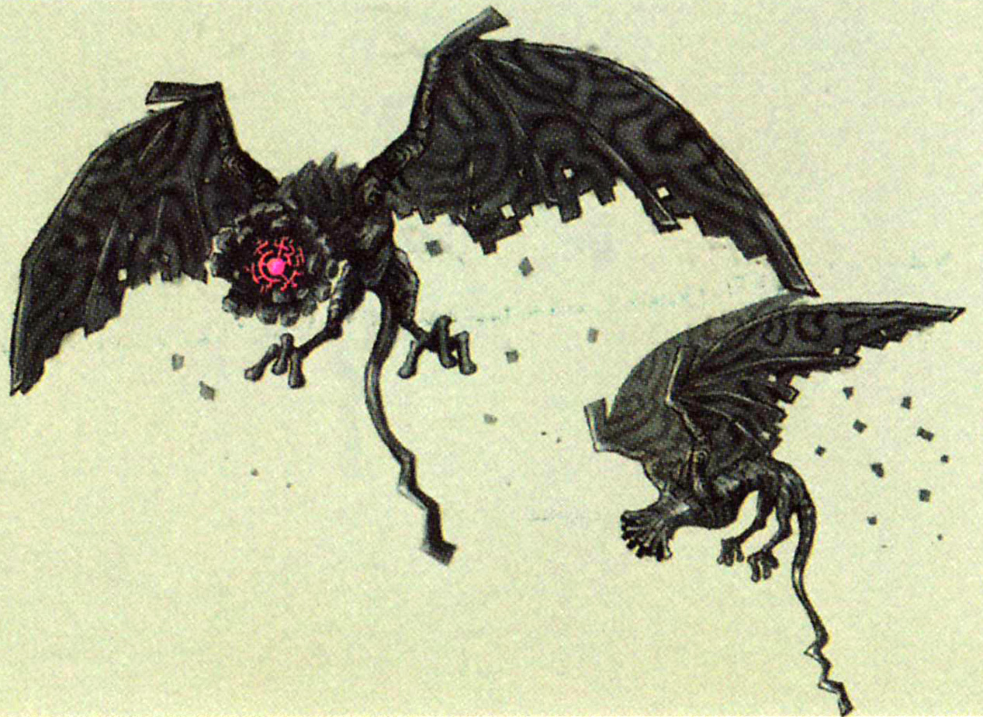

· **Kargarock:** High flying vulture-like birds with sharp beaks and talons

**a. Attacks**

* + 1. **Fist Slam:** Punches straight forward at player with medium damage multiplier.
    2. **Roll:** Rolls at player at a high rate of speed. deals medium damage as long as Goron is still hitting the player.

**b. Behaviors**

* + 1. **Grouped:** Attempts to surround player. If no Goron is within a rectangle range in front of the Goron choosing its attack, the Goron will select the roll attack. Otherwise, The gorons attempt to form a mob around the player and use Fist Slam, until room opens for a roll attack. .
    2. **Alone:** If far away from the player the Goron uses his roll attack to hit the player. When the Goron gets close to the player he prefers Fist Slam, and based on a random roll mixes in roll attacks.

**c. Stats**

|  |  |
| --- | --- |
| **Strength** | **7** |
| **Attack Speed** | **3** |
| **Physical Defense** | **8** |
| **Magical Defense** | **8** |
| **Movement Speed** | **4** |
| **Health** | **75** |

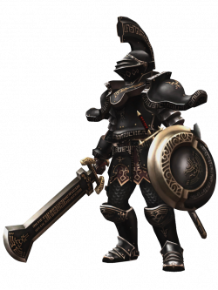

· **Darknuts:** Armor-clad dog-knights who move in packs wielding swords

**a. Attacks**

* + 1. **Fist Slam:** Punches straight forward at player with medium damage multiplier.
    2. **Roll:** Rolls at player at a high rate of speed. deals medium damage as long as Goron is still hitting the player.

**b. Behaviors**

* + 1. **Grouped:** Attempts to surround player. If no Goron is within a rectangle range in front of the Goron choosing its attack, the Goron will select the roll attack. Otherwise, The gorons attempt to form a mob around the player and use Fist Slam, until room opens for a roll attack. .
    2. **Alone:** If far away from the player the Goron uses his roll attack to hit the player. When the Goron gets close to the player he prefers Fist Slam, and based on a random roll mixes in roll attacks.

**c. Stats**

|  |  |
| --- | --- |
| **Strength** | **7** |
| **Attack Speed** | **3** |
| **Physical Defense** | **8** |
| **Magical Defense** | **8** |
| **Movement Speed** | **4** |
| **Health** | **75** |

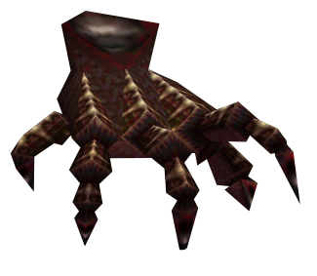

· **Floor-Masters:** Shadowy arms which spring like traps from the ground

**a. Attacks**

* + 1. **Fist Slam:** Punches straight forward at player with medium damage multiplier.
    2. **Roll:** Rolls at player at a high rate of speed. deals medium damage as long as Goron is still hitting the player.

**b. Behaviors**

* + 1. **Grouped:** Attempts to surround player. If no Goron is within a rectangle range in front of the Goron choosing its attack, the Goron will select the roll attack. Otherwise, The gorons attempt to form a mob around the player and use Fist Slam, until room opens for a roll attack. .
    2. **Alone:** If far away from the player the Goron uses his roll attack to hit the player. When the Goron gets close to the player he prefers Fist Slam, and based on a random roll mixes in roll attacks.

**c. Stats**

|  |  |
| --- | --- |
| **Strength** | **7** |
| **Attack Speed** | **3** |
| **Physical Defense** | **8** |
| **Magical Defense** | **8** |
| **Movement Speed** | **4** |
| **Health** | **75** |

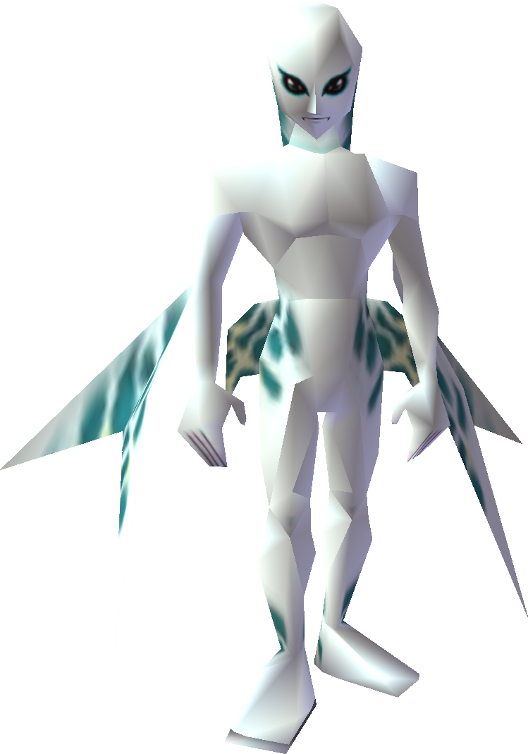

· **Zora:** Water-dwellers who move swiftly in water and leap out to attack, washing troops away in flash floods.

**a. Attacks**

* + 1. **Fist Slam:** Punches straight forward at player with medium damage multiplier.
    2. **Roll:** Rolls at player at a high rate of speed. deals medium damage as long as Goron is still hitting the player.

**b. Behaviors**

* + 1. **Grouped:** Attempts to surround player. If no Goron is within a rectangle range in front of the Goron choosing its attack, the Goron will select the roll attack. Otherwise, The gorons attempt to form a mob around the player and use Fist Slam, until room opens for a roll attack. .
    2. **Alone:** If far away from the player the Goron uses his roll attack to hit the player. When the Goron gets close to the player he prefers Fist Slam, and based on a random roll mixes in roll attacks.

**c. Stats**

|  |  |
| --- | --- |
| **Strength** | **7** |
| **Attack Speed** | **3** |
| **Physical Defense** | **8** |
| **Magical Defense** | **8** |
| **Movement Speed** | **4** |
| **Health** | **75** |

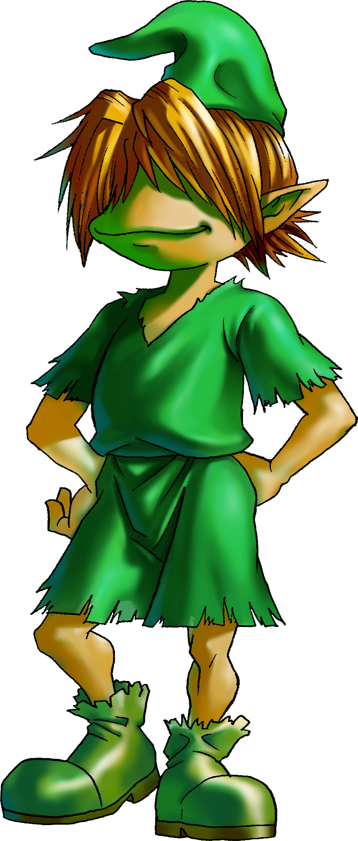

· **Kokiri:** Magical sprites who teleport around the field in a burst of foliage and snare troops in vines.

**a. Attacks**

* + 1. **Fist Slam:** Punches straight forward at player with medium damage multiplier.
    2. **Roll:** Rolls at player at a high rate of speed. deals medium damage as long as Goron is still hitting the player.

**b. Behaviors**

* + 1. **Grouped:** Attempts to surround player. If no Goron is within a rectangle range in front of the Goron choosing its attack, the Goron will select the roll attack. Otherwise, The gorons attempt to form a mob around the player and use Fist Slam, until room opens for a roll attack. .
    2. **Alone:** If far away from the player the Goron uses his roll attack to hit the player. When the Goron gets close to the player he prefers Fist Slam, and based on a random roll mixes in roll attacks.

**c. Stats**

|  |  |
| --- | --- |
| **Strength** | **7** |
| **Attack Speed** | **3** |
| **Physical Defense** | **8** |
| **Magical Defense** | **8** |
| **Movement Speed** | **4** |
| **Health** | **75** |

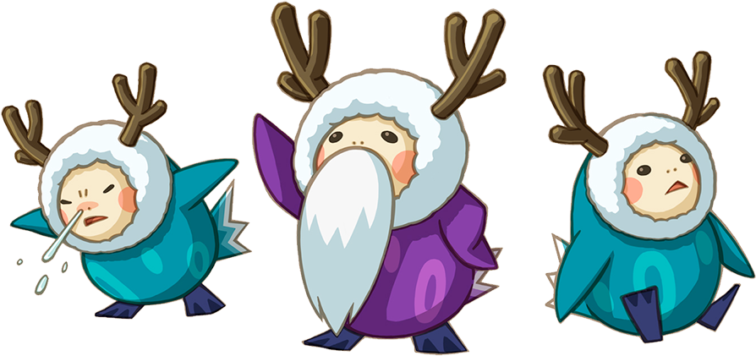

· **Anouki:** Arctic-dwelling creatures with ice-magic powers

**a. Attacks**

* + 1. **Fist Slam:** Punches straight forward at player with medium damage multiplier.
    2. **Roll:** Rolls at player at a high rate of speed. deals medium damage as long as Goron is still hitting the player.

**b. Behaviors**

* + 1. **Grouped:** Attempts to surround player. If no Goron is within a rectangle range in front of the Goron choosing its attack, the Goron will select the roll attack. Otherwise, The gorons attempt to form a mob around the player and use Fist Slam, until room opens for a roll attack. .
    2. **Alone:** If far away from the player the Goron uses his roll attack to hit the player. When the Goron gets close to the player he prefers Fist Slam, and based on a random roll mixes in roll attacks.

**c. Stats**

|  |  |
| --- | --- |
| **Strength** | **7** |
| **Attack Speed** | **3** |
| **Physical Defense** | **8** |
| **Magical Defense** | **8** |
| **Movement Speed** | **4** |
| **Health** | **75** |

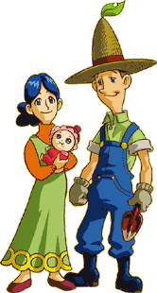

· **Hylians:** Proud warrior-knights wielding swords and bows – some even act as cavalry on horseback, others man defensive weaponry like catapults.

**a. Attacks**

* + 1. **Fist Slam:** Punches straight forward at player with medium damage multiplier.
    2. **Roll:** Rolls at player at a high rate of speed. deals medium damage as long as Goron is still hitting the player.

**b. Behaviors**

* + 1. **Grouped:** Attempts to surround player. If no Goron is within a rectangle range in front of the Goron choosing its attack, the Goron will select the roll attack. Otherwise, The gorons attempt to form a mob around the player and use Fist Slam, until room opens for a roll attack. .
    2. **Alone:** If far away from the player the Goron uses his roll attack to hit the player. When the Goron gets close to the player he prefers Fist Slam, and based on a random roll mixes in roll attacks.

**c. Stats**

|  |  |
| --- | --- |
| **Strength** | **7** |
| **Attack Speed** | **3** |
| **Physical Defense** | **8** |
| **Magical Defense** | **8** |
| **Movement Speed** | **4** |
| **Health** | **75** |